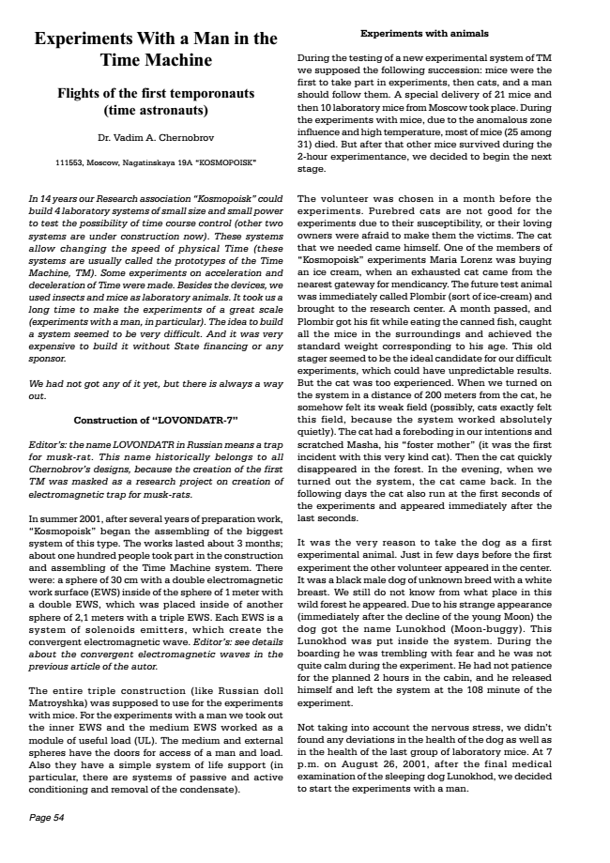
Experiments With a Man in the Time Machine
Flights of the first temporonauts (time astronauts)
Dr. Vadim A. Chernobrov
111553, Moscow, Nagatinskaya 19A KOSMOPOISK
In 14 years our Research association Kosmopoisk could build 4 laboratory systems of small size and small power to test the possibility of time course control (other two systems are under construction now). These systems allow changing the speed of physical Time (these systems are usually called the prototypes of the Time Machine, TM). Some experiments on acceleration and deceleration of Time were made. Besides the devices, we used insects and mice as laboratory animals. It took us a long time to make the experiments of a great scale (experiments with a man, in particular). The idea to build a system seemed to be very difficult. And it was very expensive to build it without State financing or any sponsor.
We had not got any of it yet, but there is always a way out.
Construction of LOVONDATR-7
Editors: the name LOVONDATR in Russian means a trap for musk-rat. This name historically belongs to all Chernobrovs designs, because the creation of the first TM was masked as a research project on creation of electromagnetic trap for musk-rats.
In summer 2001, after several years of preparation work, Kosmopoisk began the assembling of the biggest system of this type. The works lasted about 3 months; about one hundred people took part in the construction and assembling of the Time Machine system. There were: a sphere of 30 cm with a double electromagnetic work surface (EWS) inside of the sphere of 1 meter with a double EWS, which was placed inside of another sphere of 2,1 meters with a triple EWS. Each EWS is a system of solenoids emitters, which create the convergent electromagnetic wave. Editors: see details about the convergent electromagnetic waves in the previous article of the autor.
The entire triple construction (like Russian doll Matroyshka) was supposed to use for the experiments with mice. For the experiments with a man we took out the inner EWS and the medium EWS worked as a module of useful load (UL). The medium and external spheres have the doors for access of a man and load. Also they have a simple system of life support (in particular, there are systems of passive and active conditioning and removal of the condensate).
Page 54
Experiments with animals
During the testing of a new experimental system of TM we supposed the following succession: mice were the first to take part in experiments, then cats, and a man should follow them. A special delivery of 21 mice and then 10 laboratory mice from Moscow took place. During the experiments with mice, due to the anomalous zone influence and high temperature, most of mice (25 among 31) died. But after that other mice survived during the 2-hour experimentance, we decided to begin the next stage.
The volunteer was chosen in a month before the experiments. Purebred cats are not good for the experiments due to their susceptibility, or their loving owners were afraid to make them the victims. The cat that we needed came himself. One of the members of Kosmopoisk experiments Maria Lorenz was buying an ice cream, when an exhausted cat came from the nearest gateway for mendicancy. The future test animal was immediately called Plombir (sort of ice-cream) and brought to the research center. A month passed, and Plombir got his fit while eating the canned fish, caught all the mice in the surroundings and achieved the standard weight corresponding to his age. This old stager seemed to be the ideal candidate for our difficult experiments, which could have unpredictable results. But the cat was too experienced. When we turned on the system in a distance of 200 meters from the cat, he somehow felt its weak field (possibly, cats exactly felt this field, because the system worked absolutely quietly). The cat had a foreboding in our intentions and scratched Masha, his foster mother (it was the first incident with this very kind cat). Then the cat quickly disappeared in the forest. In the evening, when we turned out the system, the cat came back. In the following days the cat also run at the first seconds of the experiments and appeared immediately after the last seconds.
It was the very reason to take the dog as a first experimental animal. Just in few days before the first experiment the other volunteer appeared in the center. It was a black male dog of unknown breed with a white breast. We still do not know from what place in this wild forest he appeared. Due to his strange appearance (immediately after the decline of the young Moon) the dog got the name Lunokhod (Moon-buggy). This Lunokhod was put inside the system. During the boarding he was trembling with fear and he was not quite calm during the experiment. He had not patience for the planned 2 hours in the cabin, and he released himself and left the system at the 108 minute of the experiment.
Not taking into account the nervous stress, we didnt found any deviations in the health of the dog as well as in the health of the last group of laboratory mice. At 7 p.m. on August 26, 2001, after the final medical examination of the sleeping dog Lunokhod, we decided to start the experiments with a man.

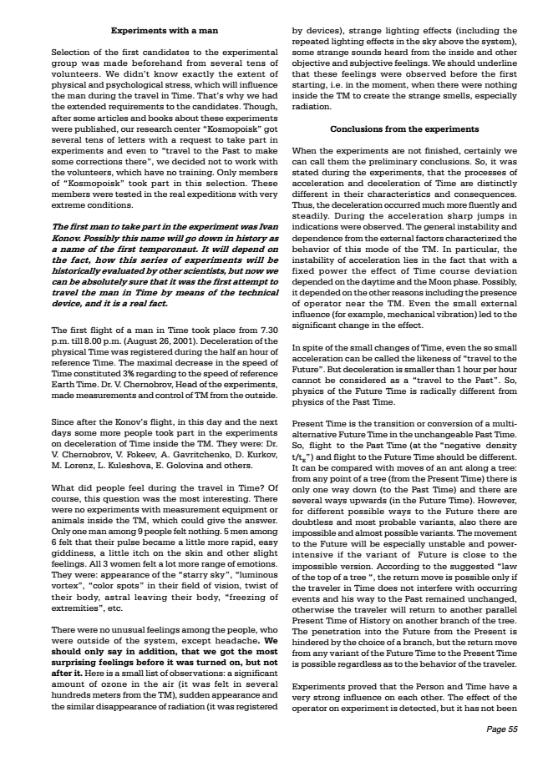
Experiments with a man
Selection of the first candidates to the experimental group was made beforehand from several tens of volunteers. We didnt know exactly the extent of physical and psychological stress, which will influence the man during the travel in Time. Thats why we had the extended requirements to the candidates. Though, after some articles and books about these experiments were published, our research center Kosmopoisk got several tens of letters with a request to take part in experiments and even to travel to the Past to make some corrections there, we decided not to work with the volunteers, which have no training. Only members of Kosmopoisk took part in this selection. These members were tested in the real expeditions with very extreme conditions.
The first man to take part in the experiment was Ivan Konov. Possibly this name will go down in history as a name of the first temporonaut. It will depend on the fact, how this series of experiments will be historically evaluated by other scientists, but now we can be absolutely sure that it was the first attempt to travel the man in Time by means of the technical device, and it is a real fact.
The first flight of a man in Time took place from 7.30 p.m. till 8.00 p.m. (August 26, 2001). Deceleration of the physical Time was registered during the half an hour of reference Time. The maximal decrease in the speed of Time constituted 3% regarding to the speed of reference Earth Time. Dr. V. Chernobrov, Head of the experiments, made measurements and control of TM from the outside.
Since after the Konovs flight, in this day and the next days some more people took part in the experiments on deceleration of Time inside the TM. They were: Dr. V. Chernobrov, V. Fokeev, A. Gavritchenko, D. Kurkov, M. Lorenz, L. Kuleshova, E. Golovina and others.
What did people feel during the travel in Time? Of course, this question was the most interesting. There were no experiments with measurement equipment or animals inside the TM, which could give the answer. Only one man among 9 people felt nothing. 5 men among 6 felt that their pulse became a little more rapid, easy giddiness, a little itch on the skin and other slight feelings. All 3 women felt a lot more range of emotions. They were: appearance of the starry sky, luminous vortex, color spots in their field of vision, twist of their body, astral leaving their body, freezing of extremities, etc.
There were no unusual feelings among the people, who were outside of the system, except headache. We should only say in addition, that we got the most surprising feelings before it was turned on, but not after it. Here is a small list of observations: a significant amount of ozone in the air (it was felt in several hundreds meters from the TM), sudden appearance and the similar disappearance of radiation (it was registered
by devices), strange lighting effects (including the repeated lighting effects in the sky above the system), some strange sounds heard from the inside and other objective and subjective feelings. We should underline that these feelings were observed before the first starting, i.e. in the moment, when there were nothing inside the TM to create the strange smells, especially radiation.
Conclusions from the experiments
When the experiments are not finished, certainly we can call them the preliminary conclusions. So, it was stated during the experiments, that the processes of acceleration and deceleration of Time are distinctly different in their characteristics and consequences. Thus, the deceleration occurred much more fluently and steadily. During the acceleration sharp jumps in indications were observed. The general instability and dependence from the external factors characterized the behavior of this mode of the TM. In particular, the instability of acceleration lies in the fact that with a fixed power the effect of Time course deviation depended on the daytime and the Moon phase. Possibly, it depended on the other reasons including the presence of operator near the TM. Even the small external influence (for example, mechanical vibration) led to the significant change in the effect.
In spite of the small changes of Time, even the so small acceleration can be called the likeness of travel to the Future. But deceleration is smaller than 1 hour per hour cannot be considered as a travel to the Past. So, physics of the Future Time is radically different from physics of the Past Time.
Present Time is the transition or conversion of a multi- alternative Future Time in the unchangeable Past Time. So, flight to the Past Time (at the negative density t/t It can E
) and be compared flight to the with Future moves Time of should an ant along be different. a tree: from any point of a tree (from the Present Time) there is only one way down (to the Past Time) and there are several ways upwards (in the Future Time). However, for different possible ways to the Future there are doubtless and most probable variants, also there are impossible and almost possible variants. The movement to the Future will be especially unstable and power- intensive if the variant of Future is close to the impossible version. According to the suggested law of the top of a tree , the return move is possible only if the traveler in Time does not interfere with occurring events and his way to the Past remained unchanged, otherwise the traveler will return to another parallel Present Time of History on another branch of the tree. The penetration into the Future from the Present is hindered by the choice of a branch, but the return move from any variant of the Future Time to the Present Time is possible regardless as to the behavior of the traveler.
Experiments proved that the Person and Time have a very strong influence on each other. The effect of the operator on experiment is detected, but it has not been
Page 55

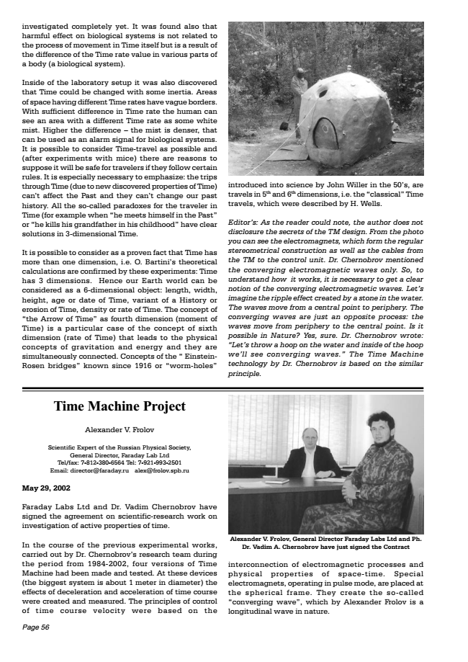
investigated completely yet. It was found also that harmful effect on biological systems is not related to the process of movement in Time itself but is a result of the difference of the Time rate value in various parts of a body (a biological system).
Inside of the laboratory setup it was also discovered that Time could be changed with some inertia. Areas of space having different Time rates have vague borders. With sufficient difference in Time rate the human can see an area with a different Time rate as some white mist. Higher the difference  the mist is denser, that can be used as an alarm signal for biological systems. It is possible to consider Time-travel as possible and (after experiments with mice) there are reasons to suppose it will be safe for travelers if they follow certain rules. It is especially necessary to emphasize: the trips through Time (due to new discovered properties of Time) cant affect the Past and they cant change our past history. All the so-called paradoxes for the traveler in Time (for example when he meets himself in the Past or he kills his grandfather in his childhood have clear solutions in 3-dimensional Time.
It is possible to consider as a proven fact that Time has more than one dimension, i.e. O. Bartinis theoretical calculations are confirmed by these experiments: Time has 3 dimensions. Hence our Earth world can be considered as a 6-dimensional object: length, width, height, age or date of Time, variant of a History or erosion of Time, density or rate of Time. The concept of the Arrow of Time as fourth dimension (moment of Time) is a particular case of the concept of sixth dimension (rate of Time) that leads to the physical concepts of gravitation and energy and they are simultaneously connected. Concepts of the  Einstein- Rosen bridges known since 1916 or worm-holes
Time Machine Project
Alexander V. Frolov
Scientific Expert of the Russian Physical Society, General Director, Faraday Lab Ltd Tel/fax: 7-812-380-6564 Tel: 7-921-993-2501 Email: director@faraday.ru alex@frolov.spb.ru
May 29, 2002
Faraday Labs Ltd and Dr. Vadim Chernobrov have signed the agreement on scientific-research work on investigation of active properties of time.
In the course of the previous experimental works, carried out by Dr. Chernobrovs research team during the period from 1984-2002, four versions of Time Machine had been made and tested. At these devices (the biggest system is about 1 meter in diameter) the effects of deceleration and acceleration of time course were created and measured. The principles of control of time course velocity were based on the
Page 56
introduced into science by John Willer in the 50s, are travels in 5th and 6th dimensions, i.e. the classical Time travels, which were described by H. Wells.
Editors: As the reader could note, the author does not disclosure the secrets of the TM design. From the photo you can see the electromagnets, which form the regular stereometrical construction as well as the cables from the TM to the control unit. Dr. Chernobrov mentioned the converging electromagnetic waves only. So, to understand how it works, it is necessary to get a clear notion of the converging electromagnetic waves. Lets imagine the ripple effect created by a stone in the water. The waves move from a central point to periphery. The converging waves are just an opposite process: the waves move from periphery to the central point. Is it possible in Nature? Yes, sure. Dr. Chernobrov wrote: Lets throw a hoop on the water and inside of the hoop well see converging waves. The Time Machine technology by Dr. Chernobrov is based on the similar principle.
Alexander V. Frolov, General Director Faraday Labs Ltd and Ph. Dr. Vadim A. Chernobrov have just signed the Contract
interconnection of electromagnetic processes and physical properties of space-time. Special electromagnets, operating in pulse mode, are placed at the spherical frame. They create the so-called converging wave, which by Alexander Frolov is a longitudinal wave in nature.

